**Linear regression**: method for finding the straight line or hyperline that best fits a set of points.

There are lots of complex ways to learn from data

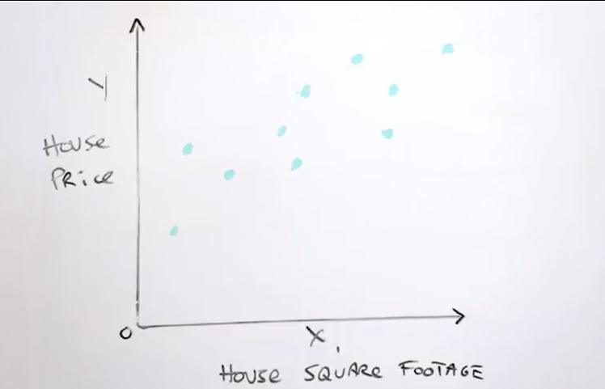

X ⟹ housing square footage - Feature

Y ⟹ House price (what we want to predict) - Labels

Try to make a model that take house square footage as and predicts house price as the output

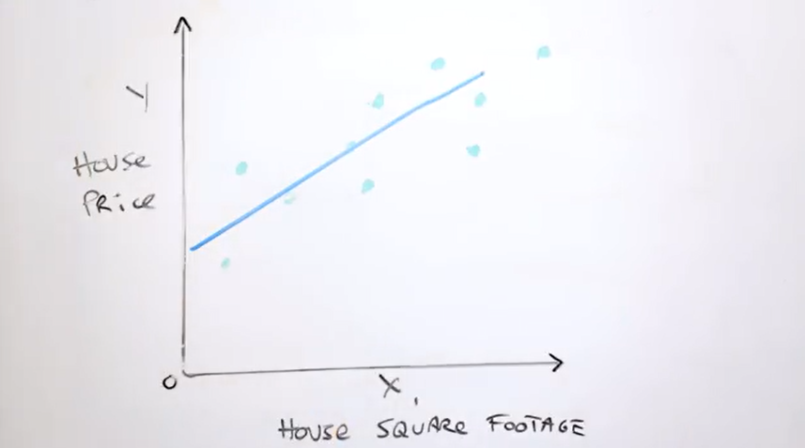

The line is a predictor of the house price. Y = mx + b

Loss: how well our line is doing from any given example.

L2 loss: loss define by squaring the difference between our model’s prediction and the true value.

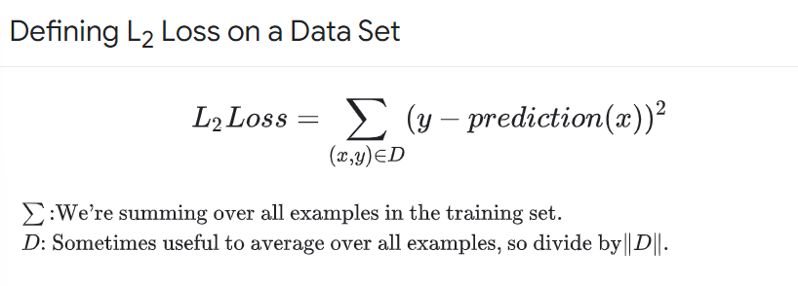

We want to minimize the loss across the entire dataset

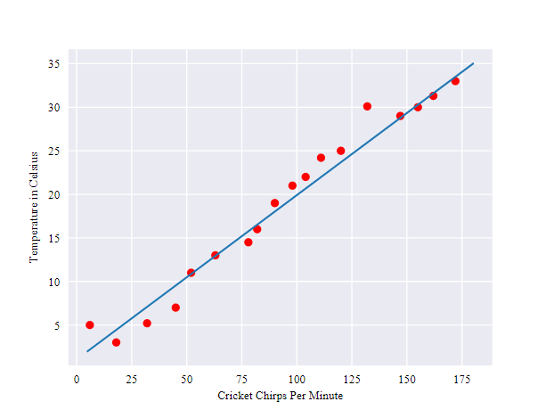Is linear. You can find a linear relationship.

**Training a model**: learning and determine good values for all the weights and the bias from labeled examples. Loss is the penalty for a bad prediction. Number that indicates how bad the model’s prediction was on a single example. The goal is to find a set of weights and biases that have low loss on average across all examples.

